EPAM University Programs DevOps L1 course Database Administration

PART 1

1. Download MySQL server for your OS on VM.

<https://dev.mysql.com/downloads/repo/yum/>

https://dev.mysql.com/doc/refman/8.0/en/linux-installation-yum-repo.html#yum-install-compatibility-el7

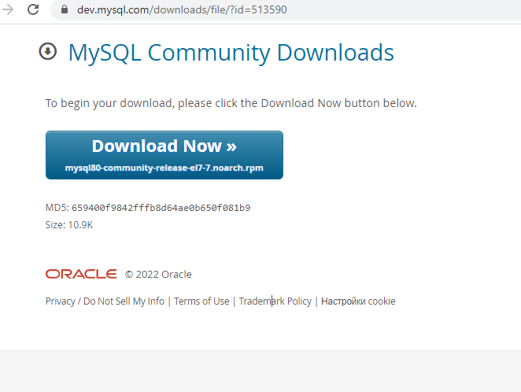

2. Install MySQL server on VM.

2.1 yum install -y mysql80-community-release-el7-7.noarch.rpm

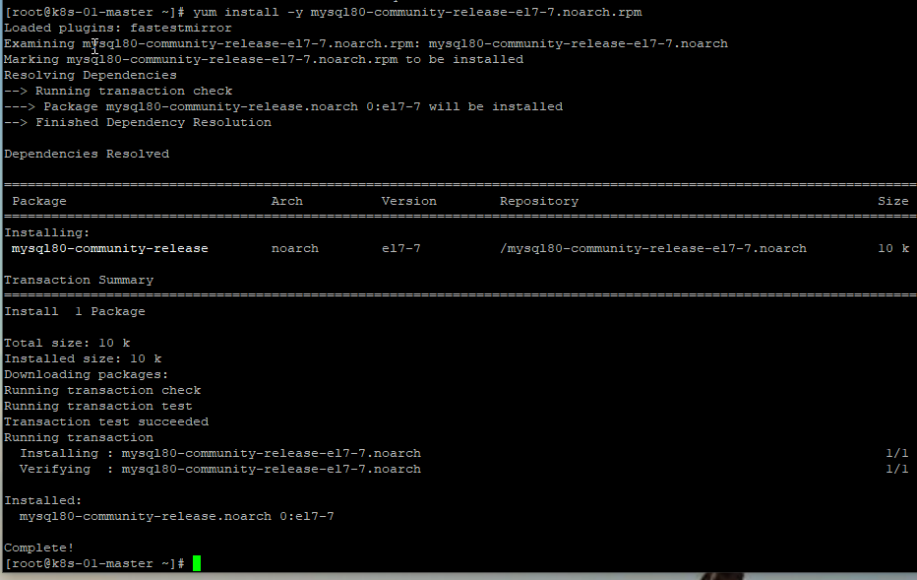

2.2 yum repolist all | grep mysql

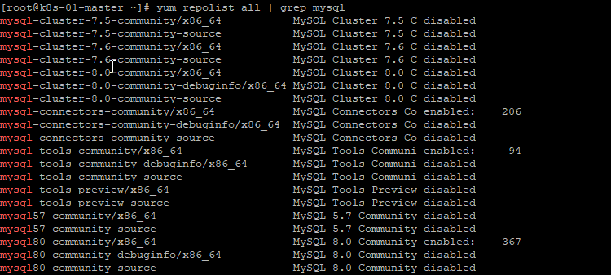

2.3 yum repolist enabled | grep "mysql.*-community.*"

mysql-connectors-community/x86_64 MySQL Connectors Community 206

mysql-tools-community/x86_64 MySQL Tools Community 94

2.4 sudo yum-config-manager --enable mysql80-community

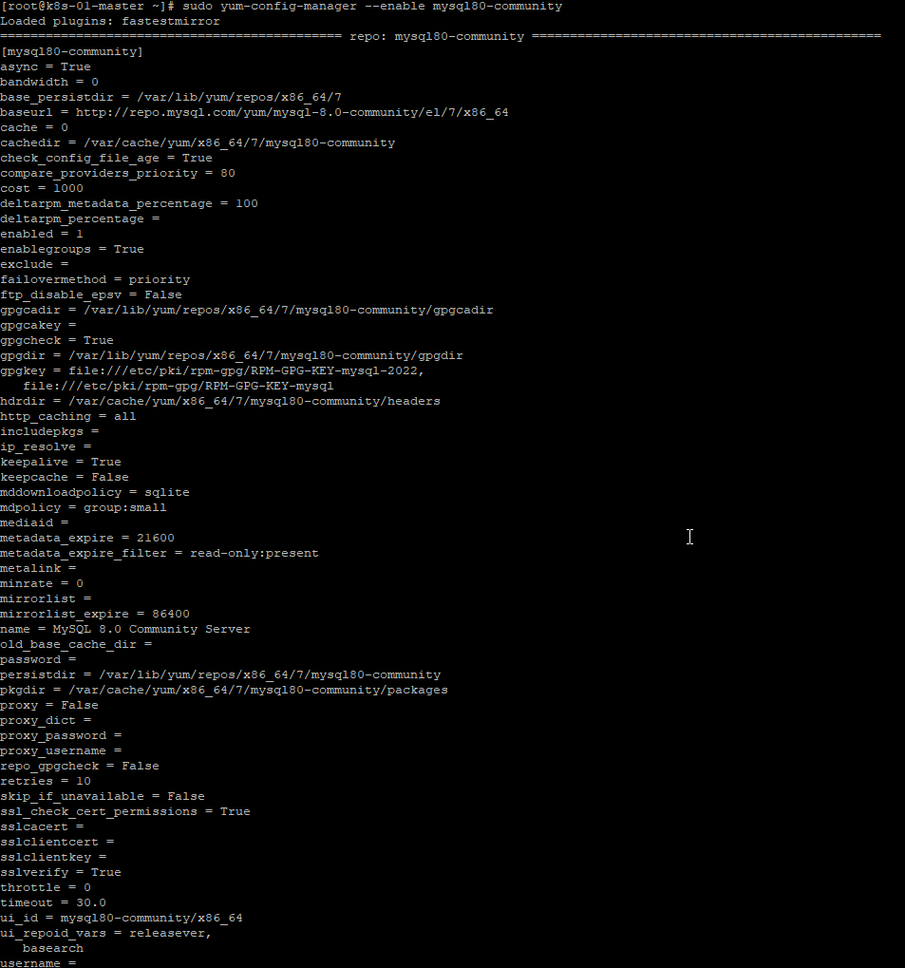

2.5 sudo yum install mysql-community-server

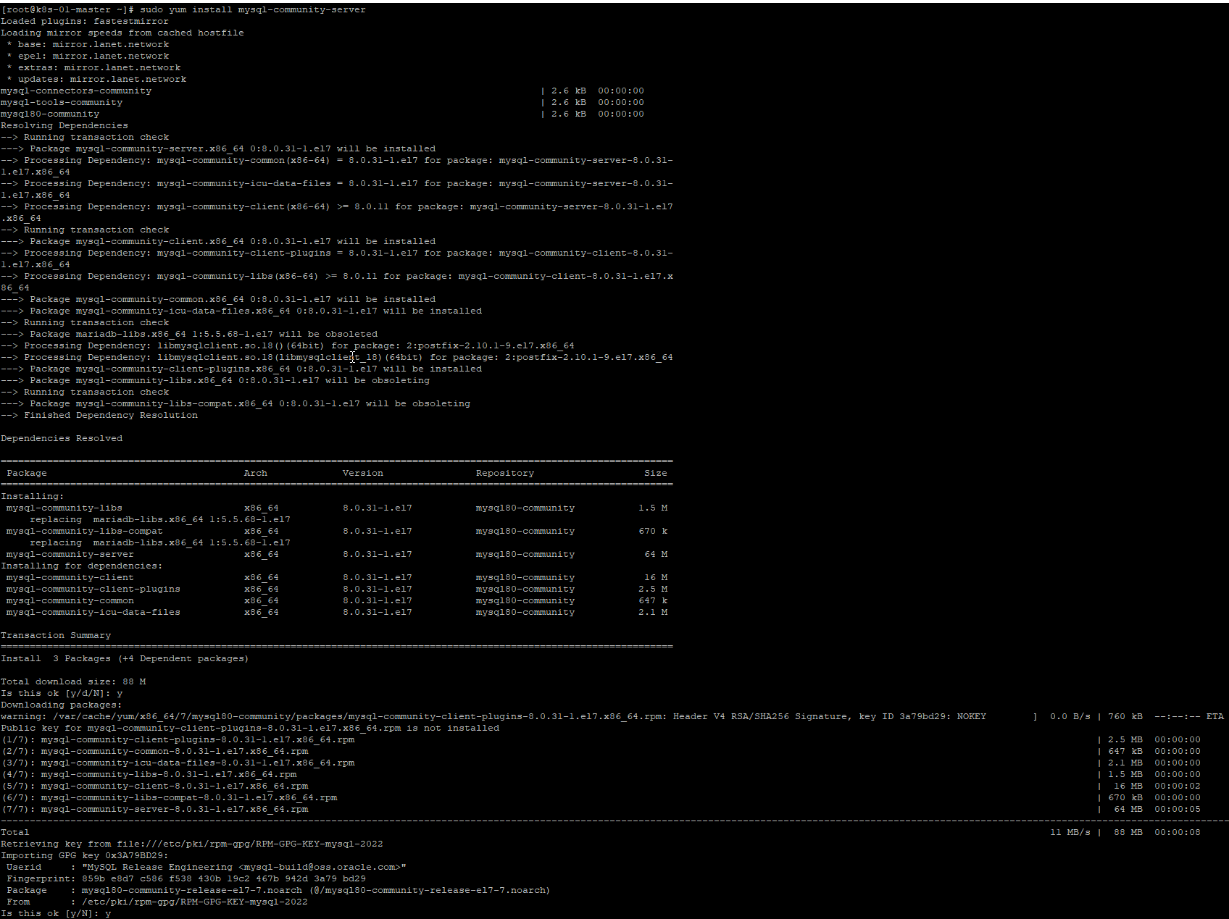

2.6 systemctl start mysqld

systemctl status mysqld

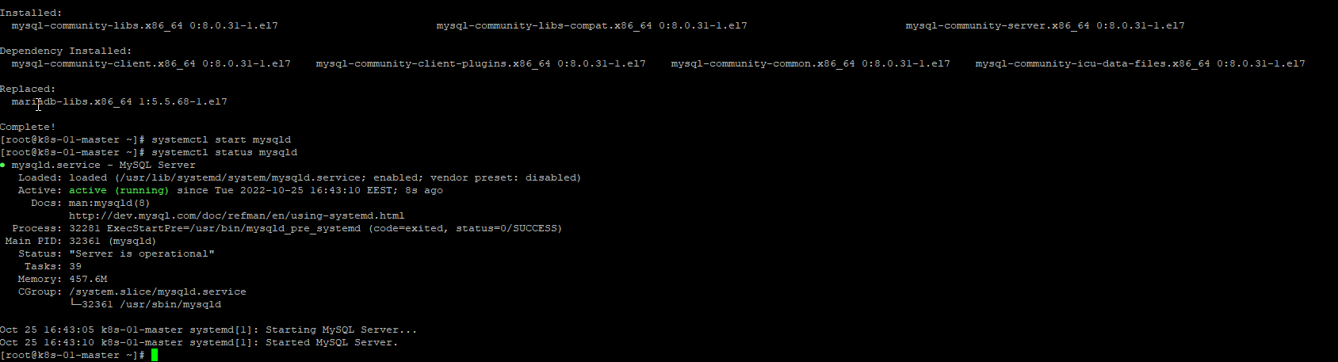

2.7 sudo grep 'temporary password' /var/log/mysqld.log

2022-10-25T13:43:07.419433Z 6 [Note] [MY-010454] [Server] A temporary password is generated for root@localhost: Z>c4;&?z<bCy

2.8 mysql -uroot -p

2.9 Change the root password as soon as possible by logging in with the generated, temporary password

mysql> ALTER USER 'root'@'localhost' IDENTIFIED BY 'MyNewPass4!';

!!! After password changes – exit and enter with new password !!!

2.10 create user - sqladmin

CREATE USER 'sqladmin'@'localhost' IDENTIFIED BY '123QWEasd!';

3. Select a subject area and describe the database schema, (minimum 3 tables)

My database “book_Shop” has three tables: authors, books and prices

Author has book or some books and books have prices.

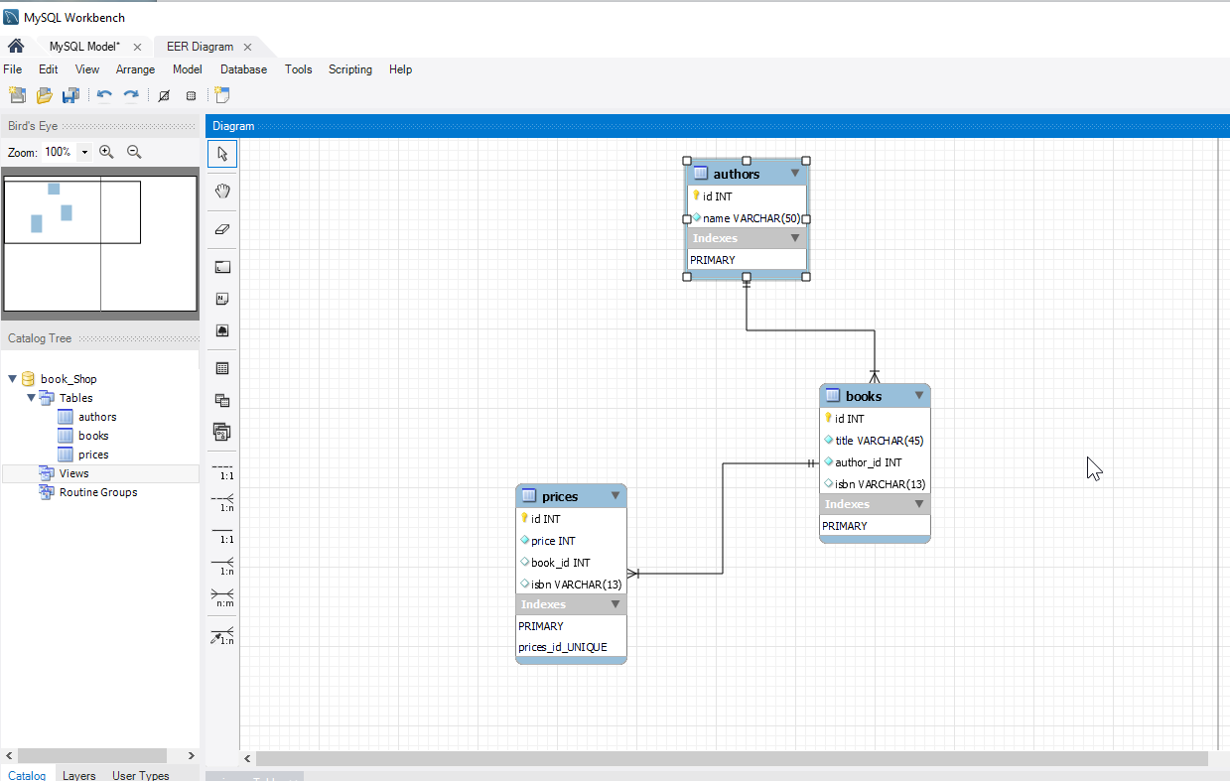

show databases;

show tables in books;

4.1 create database book_Shop;

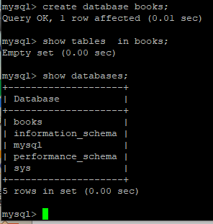

4.2 use book_Shop;

4.3 create tables:

CREATE TABLE authors (id INT NOT NULL AUTO_INCREMENT,name VARCHAR(50) NOT NULL,PRIMARY KEY (id));

CREATE TABLE books (id INT NOT NULL AUTO_INCREMENT,title VARCHAR(50) NOT NULL,isbn VARCHAR(13) NULL,PRIMARY KEY (id));

CREATE TABLE prices (id INT NOT NULL AUTO_INCREMENT,price INT NOT NULL,isbn VARCHAR(13) NULL,PRIMARY KEY (id));

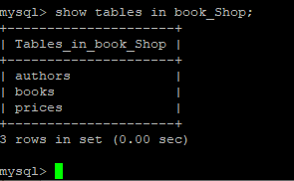

4.4 Altering tables

ALTER TABLE books ADD COLUMN author_id INT NULL AFTER isbn;

ALTER TABLE books ADD INDEX FK_books_authors_idx (author_id ASC);

ALTER TABLE books ADD CONSTRAINT FK_books_authors FOREIGN KEY (author_id) REFERENCES authors (id);

ALTER TABLE prices ADD COLUMN book_id INT NULL AFTER isbn;

ALTER TABLE prices ADD INDEX FK_prices_books_idx (book_id ASC);

ALTER TABLE prices ADD CONSTRAINT FK_prices_books FOREIGN KEY (book_id) REFERENCES books (id);

5. Fill in tables.

5.1 Inserting data rows

INSERT INTO authors (name) VALUES ('Nabokov');

INSERT INTO authors (name) VALUES ('Solgenizin');

INSERT INTO authors (name) VALUES ('Draizer');

select * from authors;

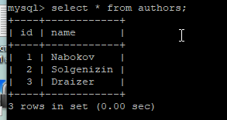

INSERT INTO books (title, author_id, isbn) VALUES ('Lolita', 1, '9789544005276');

INSERT INTO books (title, author_id, isbn) VALUES ('Archipilag Gulag', 2, '9789544005576');

INSERT INTO books (title, author_id, isbn) VALUES ('American tragedy', 3, '9789544014276');

select * from books;

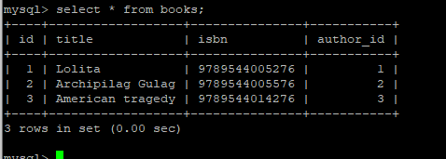

INSERT INTO prices (price, book_id, isbn) VALUES ('500', 1, '9789544005276');

INSERT INTO prices (price, book_id, isbn) VALUES ('800', 2, '9789544005576');

INSERT INTO prices (price, book_id, isbn) VALUES ('600', 3, '9789544014276');

select * from prices;

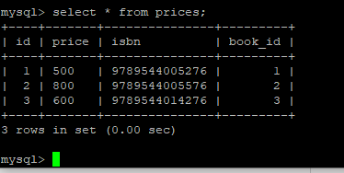

SELECT * FROM books;

SELECT * FROM authors;

Select * from pices;

6. select name from authors **where** id=2;

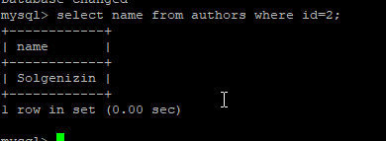

6.1 UPDATE ROWS

update books set pages = 500 **where** id = 2;

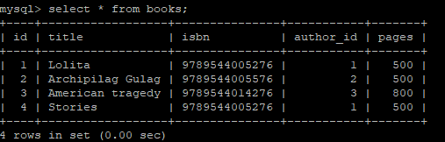

6.2 select pages from books where pages = 500 **group by** pages;

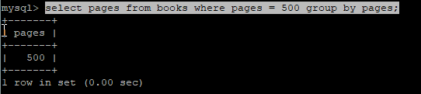

select count(pages) from books where pages = 500 **group by** pages;

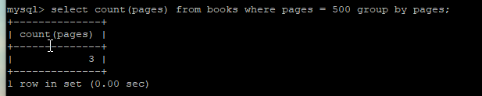

6.3 select title, pages from books order by title, pages;

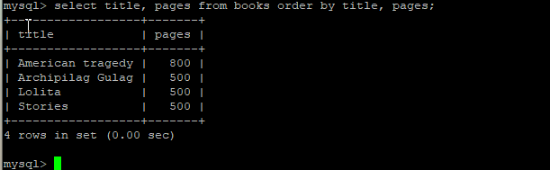

7. Execute other different SQL queries DDL, DML, DCL.

These [SQL](https://www.geeksforgeeks.org/sql-concepts-and-queries/)commands are mainly categorized into four categories as:

1. DDL – Data Definition Language
2. DQl – Data Query Language
3. DML – Data Manipulation Language
4. DCL – Data Control Language

ALTER TABLE authors ADD COLUMN age_of_living INT NULL AFTER name;

create database pats;

show databases;

use pats;

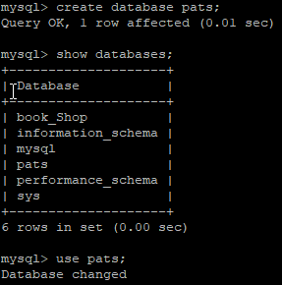

CREATE TABLE cats (id INT NOT NULL AUTO_INCREMENT,name VARCHAR(50) NOT NULL,PRIMARY KEY (id));

INSERT INTO cats (name) VALUES ('Kubik');

drop tables cats;

8. Create a database of new users with different privileges. Connect to the database as a new user and verify that the privileges allow or deny certain actions.

CREATE USER 'test'@'localhost' IDENTIFIED BY '123QWEasd!';

GRANT CREATE, ALTER, INSERT, SELECT, REFERENCES, RELOAD on *book_Shop* TO 'test'@'localhost' WITH GRANT OPTION;

INSERT INTO authors (name) VALUES ('Stoik');

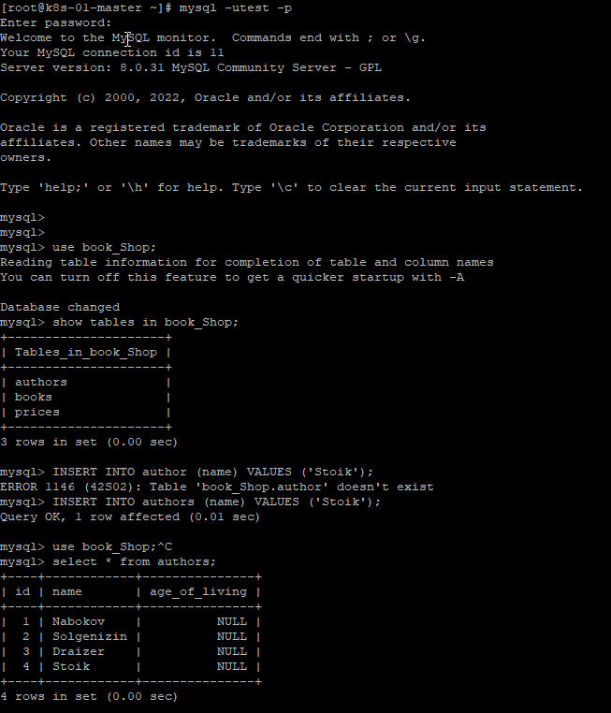

update authors set age_of_living = 68 where id = 4;

ERROR 1142 (42000): UPDATE command denied to user 'test'@'localhost' for table 'authors'

mysql>

[root@k8s-01-master ~]# mysql -uroot -p

Enter password:

mysql> GRANT UPDATE on *.* TO 'test'@'localhost' WITH GRANT OPTION;

Query OK, 0 rows affected (0.01 sec)

[root@k8s-01-master ~]# mysql -utest -p

Enter password:

use book_Shop;

mysql> update authors set age_of_living = 68 where id = 4;

Query OK, 1 row affected (0.00 sec)

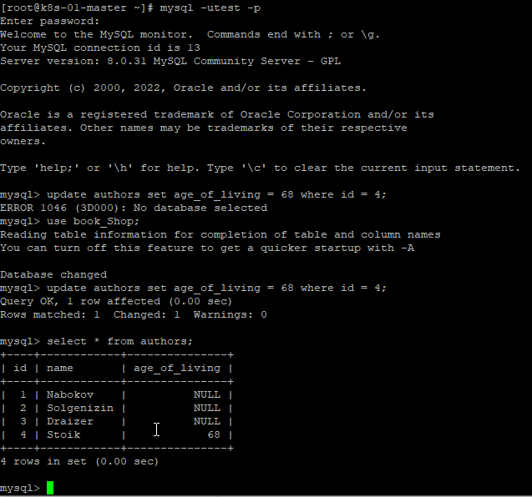

9. Make a selection from the main table DB MySQL.

mysql> show tables in book_Shop;

